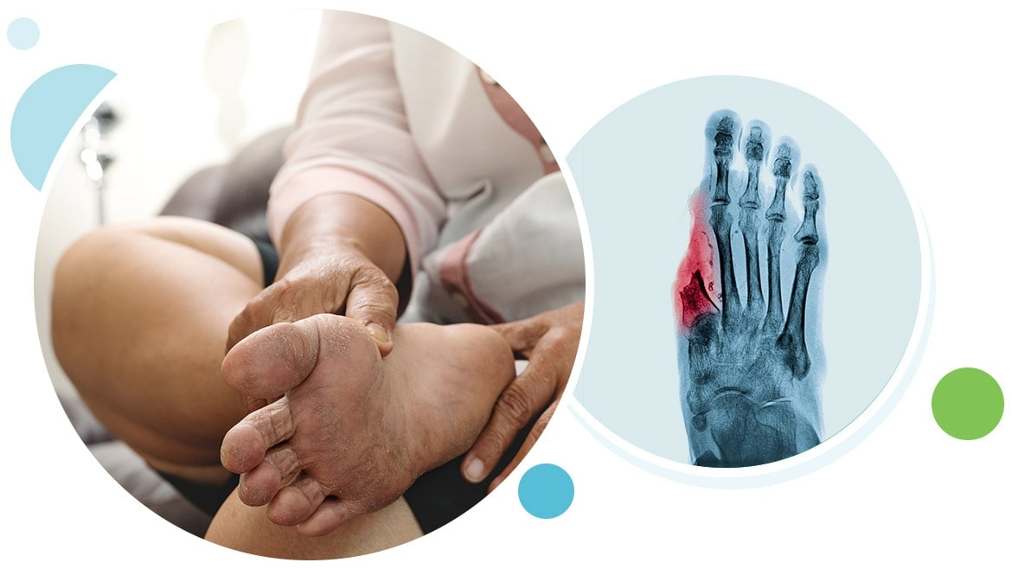

2026 UWA Limb Preservation Symposium
October 8,9 &10, 2026 | Details to Follow
University of Western Australia- Main Campus
An event dedicated to advancing continuing education in lower limb preservation and diabetic foot care across Australia. New program elements this year include dedicated sessions on cultural safety in limb preservation, revascularization strategies, and a closing gala dinner to foster further collaboration and professional connection.

Agenda Outline
Day 1- Thursday October 8
- Registration begins 30 minutes prior
- 1PM-4PM Cadaver Session for Gen Pod Lower Limb Anatomy, Injections and Ultrasound
Day 2- Friday October 9
- 7:30AM-12:00PM Cadaver Session Surgical Focus- Tibial Transport, Local Flaps, and Rebalancing (Vascular, General and Rural GP’s welcome)
- 1PM-4PM Cadaver Session covering Advanced Procedural Skills for High Risk & Gen Pod
Day 3- Saturday October 10- 8AM start
- Lecture Sessions - Full Day (Endocrinology, Vascular, ID, Cultural Safety and Behavioral Health of Limb Preservation)
- Closing Dinner Gala- $50

Fees- $100 per day or $250 for Symposium 3-Day Pass (Does not include Gala Dinner) Registration link available June 2026

Agenda items subject to change
Thank you to our sponsors:


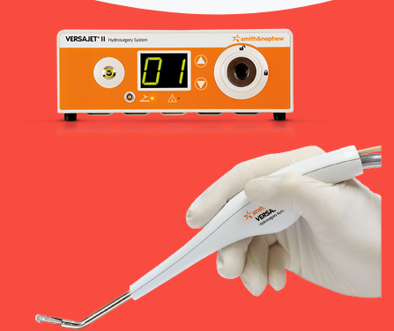
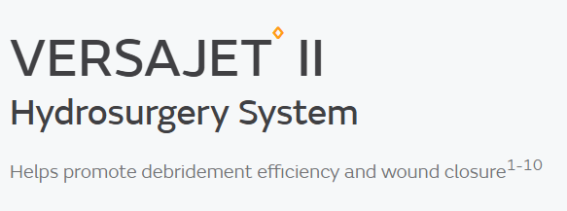
Building on the success of last year’s well-attended inaugural meeting, the University of Western Australia is proud to host the 2nd Annual Limb Preservation Symposium, an event dedicated to advancing continuing education in lower limb preservation and diabetic foot care across Australia.
This symposium brings together the multidisciplinary team involved in limb salvage to share knowledge, challenge assumptions, and collaborate in improving patient outcomes. New program elements this year include dedicated sessions on cultural safety in limb preservation, revascularization strategies, and a closing gala dinner to foster further collaboration and professional connection.
We particularly encourage participation from rural and remote healthcare providers, whose perspectives are vital in shaping effective and practical limb preservation care nationwide.

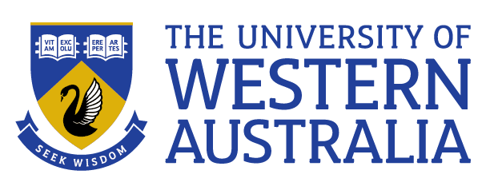
Symposium Co- Chairpersons
- Olufemi Osin
- Jamie Weaver
Symposium Committee
- Saleh Mohammad
- Omar Baarini
- Renee Silvester
******Please email jamie.weaver@uwa.edu.au for any inquiries*******
Sponsorships available:
Dinner Gala Sponsor- $6000
- Exclusive Sponsorship for Dinner Gala
- Logo across entire Dinner Gala event and pre-event advertisement
- 15- minute presentation during Dinner Gala Event
- Award attached to Sponsor
- Exclusive Industry Table during Dinner Gala
Cadaver Session Sponsor- $4000
- Exclusive Sponsorship for Cadaver session
- Product Demonstration and dedicated agenda item during session
- Logo featured in all advertisement and program material
- Industry Table all 3 days
- 15-minute presentation during Cadaver session
Platinum Sponsor- $2500
- Medium size Logo featured in all advertisement and program material
- Industry Table all 3 days

Lecture Day Agenda – October 10th
Session I
- 8:00am Welcome to Country
- 8:30-9:00am Keynote Speaker- PROF.LUCA DALLA PAOLA MD
- 9:00-9:30am Behavioural Health and Limb Preservation- Dr. Daniel Powell MD- Georgetown University
- 9:30-9:45am Nutrition Interventions in Adults with Diabetic Foot Ulcers Update- Assia Assab
- 9:35-9:55am- Osteomyelitis Update- TBD
- 9:55-10:15am- Endocrinology- Pharmacology GLP-1 Update - TBD
Morning Tea- 10:15-10:45
- 10:45-11:05am- LA only impact procedures – Omar Baarini
- 11:05-12:00pm-Patient Journey- Aboriginal Perspective – Renee Silvester
- 12:00-12:30pm Panel Discussion- TBD
LUNCH- 12:30-1:30pm
Session II- 1:30-2:45pm
- 1:30-1:50pm -Revascularisation Update Olufemi Osin
- 1:50-2:10pm- Emerging Technology and Techniques Tibial Transport- Johnson Boey
- 2:10-2:30pm- Assessment of Arterial Supply – Gabrielle McMullin
- 2:30-2:50pm- Failure of Offloading – Gabrielle McMullin
- 2:50-3:10pm- Wound care update – Donna Larsen
- 3:10-3:25pm- TCC Update- Tep Llewellyn
- 3:25-3:45pm- Amputation outcomes- 5th ray and TMA- Jamie Weaver
Afternoon Tea- 3:45-4:15pm
Session III
- 4:15-4:50pm- Future of Limb Preservation in AU Panel Discussion
- 4:50-5:00pm- Gala Preview
5:00-5:30pm- Light snacks
6:00-8:00pm- Dinner Gala
REGISTRATION LINKS:

Please see the links below for further details:
- UWA Limb Preservation Event (Day Pass, Symposium, and Gala Dinner):
View event details

- UWA Limb Preservation Sponsorship:
View sponsorship options

Day 1- Thursday October 8
- PM Cadaver Session for Gen Pod Lower Limb Anatomy, Injections and Ultrasound
12:30pm- Registration
1:00pm- Block 1
- Anatomy- Group A
- Injections- Group B
- Ultrasound- Group C
2:00pm- Block 2
- Anatomy- Group C
- Injections- Group A
- Ultrasound- Group B
3:00pm- Block 3
- Anatomy- Group B
- Injections- Group C
- Ultrasound- Group A
Blocks agenda
Anatomy- PF/Tarsal Tunnel, Lateral Ankle, 1st MPJ, Interspace
Injections- 1st MPJ, PF, STJ, Neuroma
Ultrasound- PF, Lateral Ankle, 1st MPJ, Neuroma

Day 2- Friday October 9
- 7:30AM-12:30pm Cadaver Session Surgical Focus- Tibial Transport, Local Flaps, and Rebalancing (Vascular, General and Rural GP’s welcome)
- 7:30am-9:30am- Flaps and Amputations
- 9:30-10:30am- Tendon Rebalancing
- 10:30-11:00am- Morning Tea
- 11:00am-12:30pm- Tibial Transport/MIS

Day 2- Friday October 9
- 1:00PM-4:00pm Cadaver Session covering Advanced Procedural Skills for High Risk & Gen Pod
- 1:00-1:3pm Versajet Hydrosurgery
- 1:30pm- Tenotomy
  - Flexor/Extensor
  - Peroneal Longus
  - PF
- 2:00pm- Biopsy and Suture
- 3:00pm- Nail procedures

